**Introduction to Environments**

An environment represents is a system in which the application is deployed and executed.

**Development**

The environment, where the developer makes changes in the code, commits code to the source control.

**Staging**

The environment, where the application runs on a server, from which other developers and quality controllers access the application.

**Production**

The environment, where the real end-users access the application.

Shortly, it's where the application "live" to the audience.

**Environment Setting**

**Set Environment in launchSettings.json**

in launchSettings.json

{

"profiles":

{

"profileName":

{

"environmentVariables":

{

"DOTNET_ENVIRONMENT": "EnvironmentNameHere",

"ASPNETCORE_ENVIRONMENT": "EnvironmentNameHere"

}

}

}

}

**Access Environment in Program.cs**

app.Environment

**IWebHostEnvironment**

**EnvironmentName**

Gets or sets name of the environment.

By default it reads the value from either DOTNET_ENVIRONMENT or ASPNETCORE_ENVIRONMENT.

**ContentRootPath**

Gets or sets absolute path of the application folder.

**IsDevelopment()**

Returns Boolean true, if the current environment name is "Development".

**IsStaging()**

Returns Boolean true, if the current environment name is "Staging".

**IsProduction()**

Returns Boolean true, if the current environment name is "Production".

**IsEnvironment(string environmentName)**

Returns Boolean true, if the current environment name matches with the specified environment.

**Access Environment in Controller and other classes**

using Microsoft.AspNetCore.Mvc;

using Microsoft.AspNetCore.Hosting;

public class ControllerName : Controller

{

private readonly IWebHostEnvironment _webHost;

public ControllerName(IWebHostEnvironment webHost)

{

_webHost = webHost;

}

}

**Developer Exception Page**

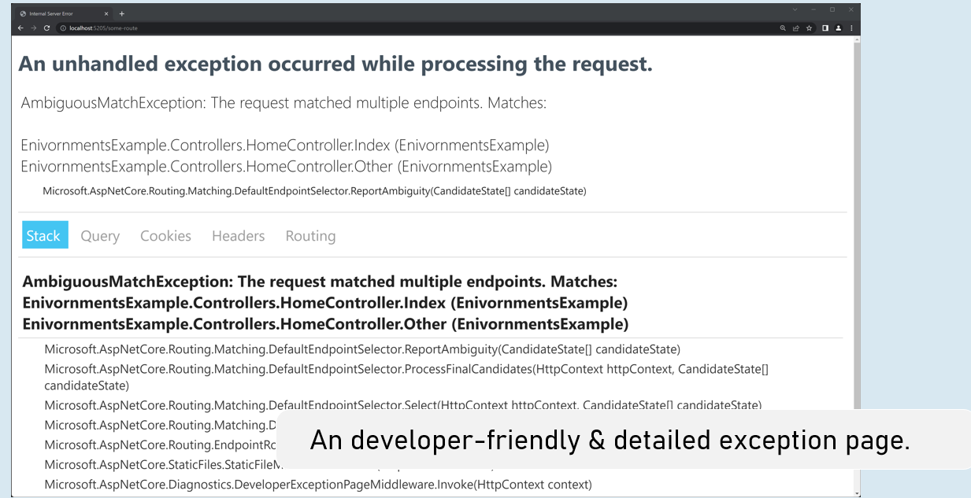

**Enable developer exception page**

in Program.cs

if (app.Environment.IsDevelopment()

{

app.UseDeveloperExceptionPage();

}

**Process-Level Environment**

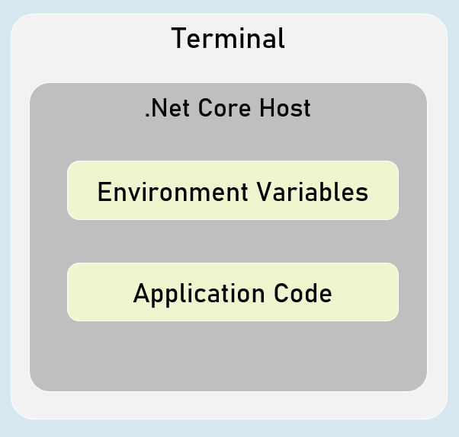

The environment variables are stored & accessible within the same process only.

**Setting Environment Variables in Process**

in "Windows PowerShell" / "Developer PowerShell in VS"

$Env:Environment="EnvironmentName"

dotnet run --no-launch-profile

**<environment> tag helper**

**include**

<environment include="Environment1,Environment2">

html content here

</environment>

It renders the content only when the current environment name matches with either of the specified environment names in the "include" property.

**exclude**

<environment exclude="Environment1,Environment2">

html content here

</environment>

It renders the content only when the current environment name doesn't match with either of the specified environment names in the "exclude" property.